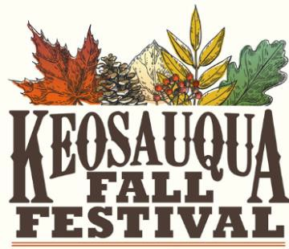
October 15 & 16, 2022
2022 VENDOR INFORMATION & RULES

Email: engagekeo@gmail.com www.keosauqua.com Phone: 319-293-3232 (Hotel Manning)

General Information - The Keosauqua Fall Festival is held annually, the second full weekend in October coinciding with the Villages of Van Buren Scenic Drive Festival. Show hours are Saturday the 15th, 9am - 5pm and Sunday the 16th, 10am - 4pm. Vendors must be open and staffed both days, the entire time. No weather guarantees or refunds. There will be a limited number of vendors allowed per product type.

Application Deadline - The guaranteed placement application deadline is September 1, 2022. To be considered for the EARLY BIRD discount ($10) you must submit your application prior to July 1, 2022.
Festival Set-up Schedule - Thursday, October 13th 12pm - 4pm & Friday, October 14th 10am - 6pm. All vendors must check in before setting up. A representative of Engage Keosauqua will be in front of the Hotel Manning to check you in and show you to your spot. ALL SPOTS ARE ASSIGNED. No returning vendors will be guaranteed the spot they have had previous years. Vendors are responsible for providing their own tent, extension cords, tables and chairs. Vendor spots will be set up in rows, side by side and back to back on pavement.

Cancelations - Cancelations up to two weeks prior to the Festival will be refunded, less a 25% administrative fee. Canceling within two weeks prior to Festival, for any reason, will result in the forfeit of your fee.

Rules and Regulations
Permits - Vendors are responsible for obtaining the appropriate permits from local authorities for their operation. An Iowa Sales Tax Number must be provided on the attached application, if you don’t have a Sales Tax number one must be obtained at http://tax.iowa.gov. All food vendors must display current food permit from the Iowa Department of Inspections and Appeals.

Vehicle Access - Vendors will be allowed to utilize vehicles to move equipment and goods to the site only at times designated by the Festival, generally before the start of the Festival or after the Festival closes each day. Vehicles MUST be off the street before the Festival begins. Vehicles will not be allowed into the Festival area during the Festival’s hours or they are subject to being towed. Any exceptions must be approved by the Fall Festival Committee.
Trash - Vendors must dispose of all trash in the dumpsters provided for the Festival, not in the trash cans in the park. Vendors are expected to clean up their area regularly during the Festival and thoroughly at the closing of the Festival.

Sub-letting - Transfer or subletting of booth space is not allowed. All products and/or services offered for sale during this Festival must be the same products and/or services approved from the application.
Liability and Indemnification - The vendor agrees to hold harmless the City of Keosauqua & Engage Keosauqua and to assume all liability for damage or injury, including death, to property or persons arising from accidents or other causes incidental to the vendors’ participation in the Festival and hereby releases the City of Keosauqua and Engage Keosauqua from any liability whatsoever.

We reserve the right to dismiss any vendor at any time, without refund, due to inappropriate behavior or neglect of rules and regulations.

VENDOR APPLICATION FORM
October 15 & 16, 2022
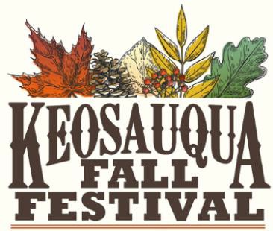
Email: engagekeo@gmail.com www.keosauqua.com

This agreement is made and entered into by and between Engage Keosauqua and
Business Name: Person(s):

Address:
City: State:
Zip:

E-mail:
Phone:
Iowa Sales Tax ID:

OUTDOOR CRAFT SHOW (10x10) | $85 | $
ADDITIONAL SPACE(S) | $25 | $
ELECTRICITY | $15 | $
FOOD VENDOR | $150 | $
EARLY BIRD DISCOUNT | ($10) | $

In the space below, please provide a description of the product you will be selling. If you are a food vendor, please provide a detailed menu. You may attach a sheet of paper if necessary.
Fee Calculator
TOTAL ENCLOSED
$
PAYMENT NOTICE
Payment by personal check or money order must be received when application is submitted.
Additional fees may apply if signing up after September 1, 2022.
Make checks payable to: Engage Keosauqua, P.O. Box 313, Keosauqua, IA 52565
Signature of Applicant
Date
By signing above, you have agreed to the Festival Information and Rules provided in the first page.
________________________________________________________________________________________

________________________________________________________________________________________
________________________________________________________________________________________

HAVE YOU EXHIBITED AT THIS FESTIVAL BEFORE? YES or NO IF YES, HOW MANY YEARS? IF NO, HOW DID YOU LEARN ABOUT THE FESTIVAL?
Office Use Only
Date Received / / Check # Accepted: Yes or No Booth Location Confirmation Sent/Date / /

